**Ken Tian Yi Xu**

**Week 2 journal**

* Troubleshoot (get to know Lektor)
* Lektor script

Friday Nov 22

Grouped as a team and decided to use Lektor, it is the easiest one, the quickstart command just makes the whole project really easy to operate. Then we separated the task Prince and Parth are going to figure out about which provider we are using, my task will be to figure out about the script (e.g. how to change template in lektor, how to put animation, etc.).

Saturday Nov 23

Last week, I couldn’t edit the content of the project I didn’t know how to search where my projet is located. I asked ChatGPT about and this was his answer.

**Method 1: Use Finder**

1. Open **Finder**:
   * Click the blue-and-white face icon in your Dock (bottom of the screen).
2. Navigate to the Project Directory:
   * From your Terminal output, the project was created in /Users/tianyixu/Week2.
   * In Finder, go to:

Copy code

Macintosh HD > Users > tianyixu > Week2

* + Or, press Cmd + Shift + G in Finder, paste the path /Users/tianyixu/Week2, and press **Enter**.

1. Open the Folder:
   * Once inside the Week2 folder, you’ll see your Lektor project files.

**Method 2: Open from Terminal**

If you’re already in the Terminal, you can open the folder directly in Finder:

1. Use the open command:

bash

Copy code

open /Users/tianyixu/Week2

1. This will open the project folder in Finder.

**Method 3: Use Spotlight Search**

1. Press Cmd + Space to open **Spotlight Search**.
2. Type Week2 (your project name) and wait for it to appear in the search results.
3. Click the folder to open it in Finder.

For me the best method was the second one, so once I open the project I can just edit and create the projet I want, put the animations and the content we would want to put.

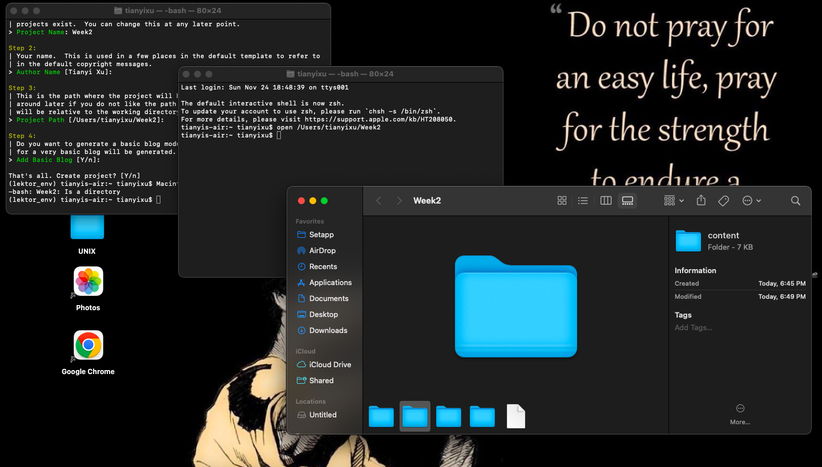

In the Project there are multiple folders : contents, models, assets and templates. For our project we would mainly use the content folder to put our content and the templates folder to do our animations. To edit those folders, since I am on macOS i will be using the original app given by Apple the TextEdit add which is the alternative of Files on Windows